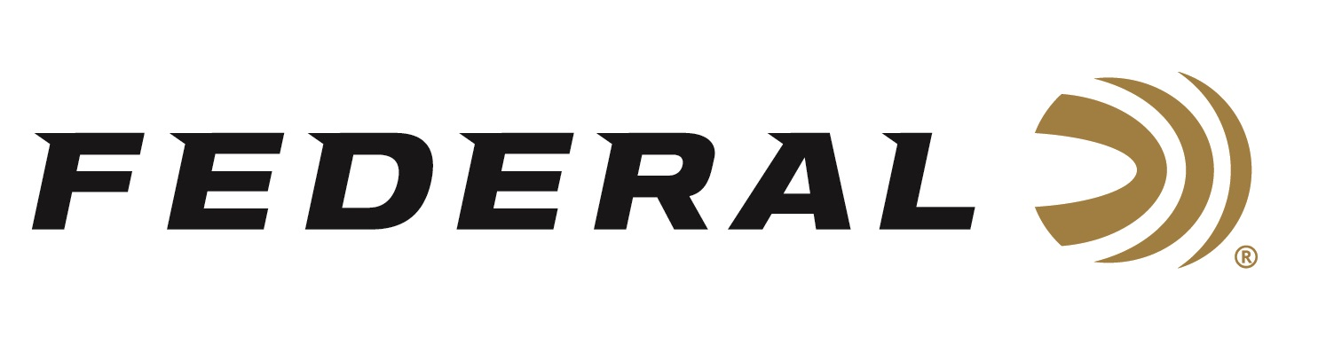

FOR IMMEDIATE RELEASE

Federal Ammunition Sponsored Shooters Bring Home
World Cup Medals

ANOKA, Minnesota – October 21, 2019 – Two-time Olympic men’s skeet gold medalist Vincent Hancock claims a silver medal at the ISSF World Cup in Al Ain, UAE. Caitlin Connor wins gold in mixed team event.

To qualify for the finals of the International Shooting Sport Federation competition, Hancock tied with five other shooters finishing with 124/125. After a shoot-off for bib order, Hancock emerged with bib #1. In the men’s skeet finals, Italy’s Luigi Lodde shot a perfect 60/60 to win the gold medal, while Hancock shot 59/60 to take the silver.

Competing on the women’s side, Caitlin Connor, representing the USA, set a world record and wins a gold in a unique event at the ISSF, the mixed team event. Contested for the first time, a male and female shooter from different countries were paired in a friendly competition to close out the ISSF international shotgun calendar for 2019. Connor and her Australian partner won the gold. Connor also placed 6th in the women’s skeet competition. In the women’s skeet qualification event, Connor shot a 123 which tied the current world record.

Federal is the official shotshell ammunition sponsor and supplier of USA Shooting, a non-profit organization that promotes the shooting sports and prepares American athletes to bring home gold. Learn more about USA Shooting at: www.usashooting.org. For more information on Federal ammunition, visit www.federalpremium.com.

Press Release Contact: JJ Reich
Senior Communications Manager - Firearms and Ammunition
E-mail: VistaPressroom@VistaOutdoor.com

About Federal Ammunition
Federal, headquartered in Anoka, MN, is a brand of Vista Outdoor Inc., an outdoor sports and recreation company. From humble beginnings nestled among the lakes and woods of Minnesota, Federal Ammunition has evolved into one of the world's largest producers of sporting ammunition. Beginning in 1922, founding president, Charles L. Horn, paved the way for our success. Today, Federal carries on Horn's vision for quality products and service with the next generation of outdoorsmen and women. We maintain our position as experts in the science of ammunition production. Every day we manufacture products to enhance our customers' shooting experience while partnering with the conservation organizations that protect and support our outdoor heritage. We offer thousands of options in our Federal Premium and Federal® lines-it's what makes us the most complete ammunition company in the business and provides our customers with a choice no matter their pursuit.

###

